1. Create a VM from azure portal with Visual Studio 2017 installed.  Enter “Visual Studio” on the top search bar on the portal – Select Visual Studio in the Market Place to see the next screen as below.

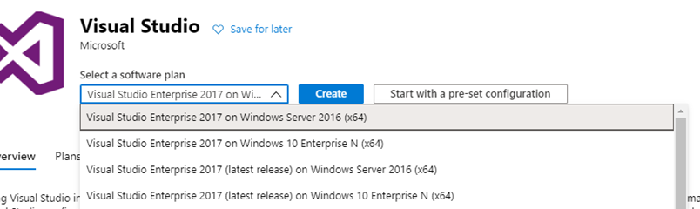

1. Select Visual Studio Community 2017 on Windows Server 16 (x64) from the combo box.
2. Click on Create that will take you to the basic tab of VM creation.
   1. Enter an new resource group name as “dev” .
   2. Fill in the name of the VM as you like. Region as East US and the rest of the fields.
   3. For inbound ports Ensure RDP/SSH/HTTP/HTTPS ports are enabled.
   4. Let the license type be “Windows server”.
   5. In the Disk tab ensure disk type is “Standard SSD”
   6. Ensure you disable Boot diagnostics. ( OFF).
3. Review + Create - > Create. VM will be ready in next 5- 10 minutes.
4. RDP to it once its ready. You will see this VM will have VS 2017 installed on it.
5. You need to change the IE settings to enable download of software on the VM –
   1. Go to IE setting – Security tab - > Custom Level -> File Download -> Enable..  With this change you should be able to download software on the VM.
6. On the VM Install .Net Core 3.1 from the link [https://dotnet.microsoft.com/download/dotnet-core/3.1](https://urldefense.com/v3/__https:/dotnet.microsoft.com/download/dotnet-core/3.1__;!!EIXh2HjOrYMV!MzOzfXFYLzk1bi53MTlQA_c93WOTOupgEVRV21jFYmCv_Ovr1zHvdHmKWPhSMMyb6A$). You need to download Windows ( x64) version . Install the software.
7. Install AZ CLI .  From the link [https://docs.microsoft.com/en-us/cli/azure/install-azure-cli-windows?view=azure-cli-latest](https://urldefense.com/v3/__https:/docs.microsoft.com/en-us/cli/azure/install-azure-cli-windows?view=azure-cli-latest__;!!EIXh2HjOrYMV!MzOzfXFYLzk1bi53MTlQA_c93WOTOupgEVRV21jFYmCv_Ovr1zHvdHmKWPhjyYacow$)  Download the MSI and install it on the VM.
8. Install Azure Function App Core tools from <https://docs.microsoft.com/en-us/azure/azure-functions/functions-run-local?tabs=windows%2Ccsharp%2Cbash#v2> . Download and install V3.x Windows X64 version.
9. Install HTTPREPL utility by executing following command on the windows command prompt (CMD) . “dotnet tool install -g Microsoft.dotnet-httprepl”
10. Install Chrome browser.
11. Download the lab code for all the labs using chrom browser at “https://github.com/MicrosoftLearning/AZ-204-DevelopingSolutionsforMicrosoftAzure”